**Virtual Machine**

* **Ashwin Harish P**

**What is Virtual Machine**

A Virtual Machine (VM) is a software-based emulation of a physical computer. It runs an operating system (OS) and applications just like a physical machine, but it's hosted on a real physical machine, often referred to as the host. The VM behaves as a separate computer, even though it shares the underlying physical hardware with other VMs. A VM runs on top of a hypervisor, which is a layer of software that manages and isolates multiple VMs on a single physical machine.

**Types of hypervisors**:

1. **Type 1 (Bare-metal)**: Installed directly on the hardware  
   Examples: VMware ESXi, Microsoft Hyper-V, Xen
2. **Type 2 (Hosted)**: Runs on top of an existing OS  
   Examples: VMware Workstation, Oracle VirtualBox

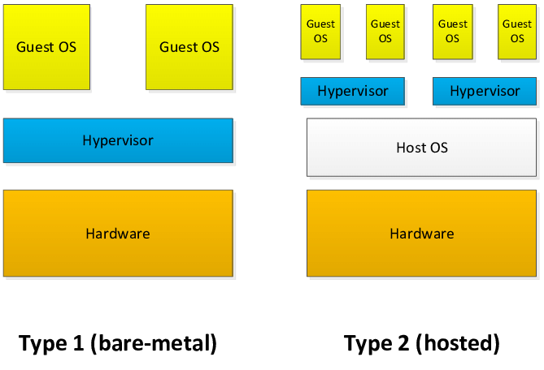

**Components of Virtual Machine**:

* Virtual CPU (vCPU)
* Virtual RAM
* Virtual Hard Disk
* Virtual Network Interface
* Virtual BIOS or UEFI

**Key Features of Virtual Machines**

* **Isolation:** Each VM runs separately from others and from the host system.
* **Portability:** VMs can be moved or copied easily to another computer or server.
* **Snapshotting:** You can take a snapshot (save the current state) and restore it later.
* **Security:** VMs are sandboxed — if one gets attacked, it doesn’t affect the host or other VMs.
* **Resource Allocation:** You can control how much CPU, RAM, and storage a VM can use.

**Advantages of VMs**

* Efficient hardware utilization
* Easy to test different OSes or software versions
* Simplifies backup and disaster recovery
* Can run legacy applications on older OS versions
* Ideal for development, testing, and training environments

**Disadvantages of VMs**

* Slower performance compared to physical machines (due to virtualization overhead)
* High resource usage if many VMs are run simultaneously
* Complex management in large-scale environments

**Comparison: Virtual Machine vs Physical Machine**

| **Feature** | **Virtual Machine** | **Physical Machine** |
| --- | --- | --- |
| Deployment | Software-based | Hardware-based |
| Resource Use | Shared and dynamic | Dedicated |
| Isolation | High | Very high (but fixed) |
| Flexibility | High | Low |
| Portability | Easy to move/copy | Not portable |